**BashBit**

Game Design Document

Written by Paul Daniel Mihai

Version 2.10

Version History:

Version 1.00: Created Document

Version 1.10:

* Removed Menu from Core Mechanics.
* Modified the description on Achievements.
* Implemented Reference Art.
* Went into more depth with the Soundscape.
* Provided a visual on the controls for the game.

Version 2.00:

* Added extra reference and explanation for Art.
* Added an excessively high in depth description of gameplay with sketches.

Version 2.10:

* Corrected a few misinterpretations
* Added UI section

**Overview:**

Hook:

* Guide a powerful brawler-bot through a virtual world gone wrong. The brawler-bot is to bash through peculiar obstacles and locate the source of corruption to eliminate it.

Pillars:

* Epic Bosses
* Pressuring Platforming Puzzles
* Immersive Strategic Combat
* Bizarre Linear Levels

Core Mechanics:

* Combat Oriented Movement
  + Basic movement dynamics relying on melee recoil to boost yourself to more difficult places.
* Advanced Fist Combat
  + Rapid punches and Chargeable power punches.
  + Damage Threshold for flinching and knockback.
* Elusive Destructible Puzzles
  + Puzzles are never how they appear, some are hilariously easy to pass while some make you regret underestimating it.
  + Some intimidating puzzles can be easily muscled through without using your brain while some puzzles require you to dig deeper than what you currently see.
* Achievements
  + Actively keeps track of your progress throughout the game and allows you to advance in the game.
  + Grants access to various secrets hidden across the game and determines the current state of NPCs.
  + Some are hilariously easy to do while some require extreme determination to locate and/or obtain.
  + Most of the achievements are optional and are purely for bragging rights or humour, however there is a reward for anyone who obtains ALL achievements in the game. (Ghost Skin)

Features:

* Reinvented Combat
  + Tear down every single puzzle and enemy with only your bare hands
  + Discover hilarious ways to dispatch bosses and enemies using your surroundings.
* Exotic Puzzles
  + Forget all common sense as you break through the most elusive puzzles
* 10+ Unique Levels
  + Progress through each level with their own sets of challenges.
  + Each stage ends with a boss battle
* Peculiar Personalities
  + All characters have their own sets of personalities, minor enemies goofing off and making philosophical nonsense, Bosses with unusual quirks in the background.
  + All enemies have their own death animations, and all characters have a unique voice sound.

Art Style:

* Futuristic science-fiction styled levels with alien patterns and alien life forms. Slightly realistic but simplistic characters and environment allow for better performance and to give a better sense of being in a virtual world.

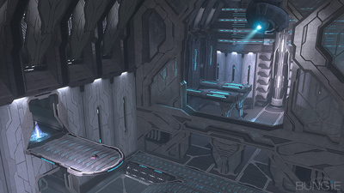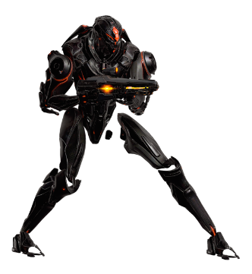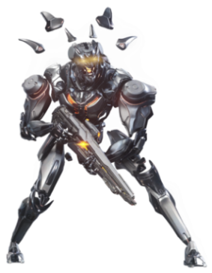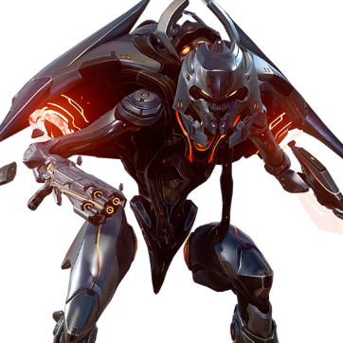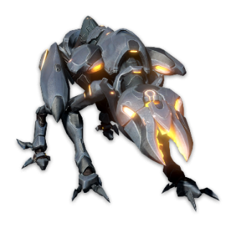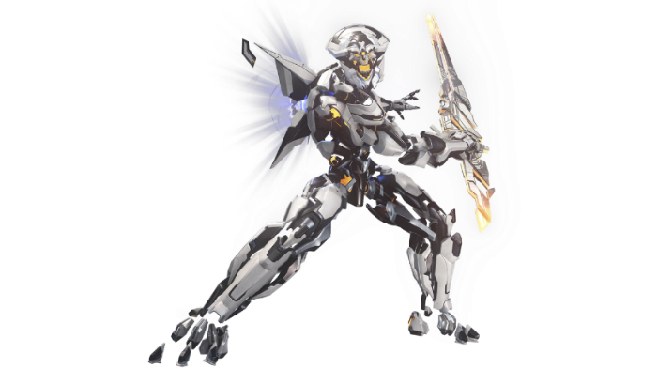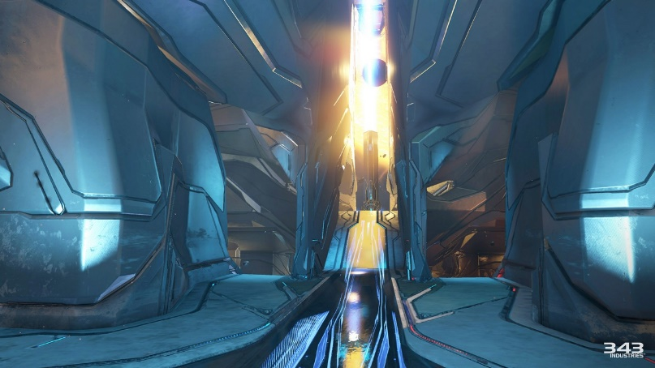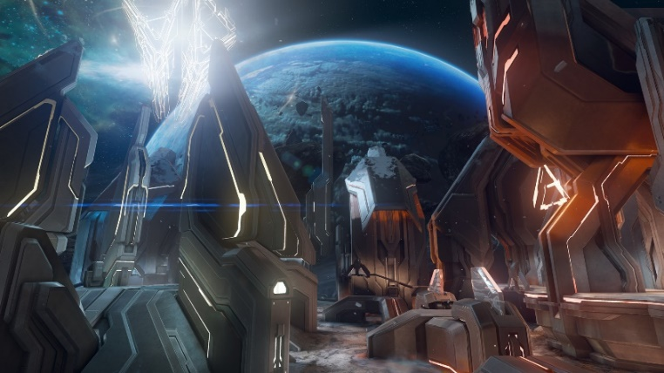

I really liked Halo 4 and 5’s Forerunner design, and I would implement a similar style to how the maps are made as well as how the enemies look like especially as you progress through the game.

The alien bosses will also have a minor resemblance to the Flood from Halo 2 + 3, and a hint of Lovecraft.

Audio:

* An electronic intense soundtrack.
* The music in each level will change accordingly to the current intensity.
  + Intensity 0:
    - Idling in a safe zone
  + Intensity 1:
    - Solving a calm puzzle
    - Fighting lesser enemies
  + Intensity 2:
    - Navigating through a hazardous room
    - Fighting a Mini-boss
  + Intensity 3:
    - Being chased by an invincible enemy
    - Solving a timed puzzle
    - Fighting a Boss
  + Intensity 4:
    - Fighting a Very Angry Boss
* Robotic sounds for voices as well as enemy screeching for death animations.
* Sci-fi sounds for performing attacks.
  + Swooshes for swings.
  + Metal clang for hitting static obstacles
  + Metal strike mixed with electrical noises and robot sounds when hitting an enemy, the robot voice depending on the enemy itself.
  + Loud metal impact sounds for hitting power shots, accompanied by robot screeching depending on what you hit.
  + Laser sounds for ranged attacks.
  + Electric sounds when projectile or laser hits something, robot noises if it hits the player.
  + Fleshly aliens will have a different sound compared to the machinery, with flesh splatter sounds, hissing and organic screeching.

Interaction:

* Mouse and Keyboard Controls
  + Movement Controls
  + Interaction with UI
  + Melee Handling

**Controls:**

Keyboard:

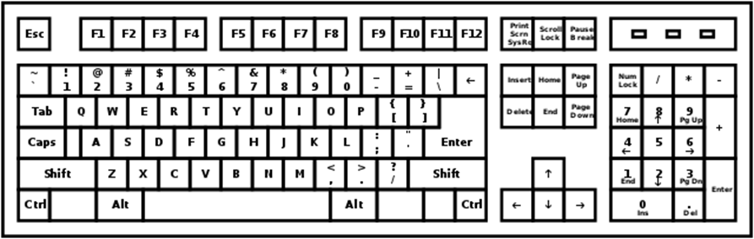

Pause/Unpause

Jump

Move Left

Move Right

Crouch/Fall

Mouse: Aim Punch

Left Click: Throw Punch (Hold: Charge Punch)

Release info:

* This strategy-puzzle, side-scrolling, beat-em-up platforming adventure will be released on PC, for ages 13+.
* This will be published on Steam for convenience.

**Gameplay:**

UI:

**HUD:**

The HUD is what shows up at the top of the screen throughout each and every single level, serving various roles described below.

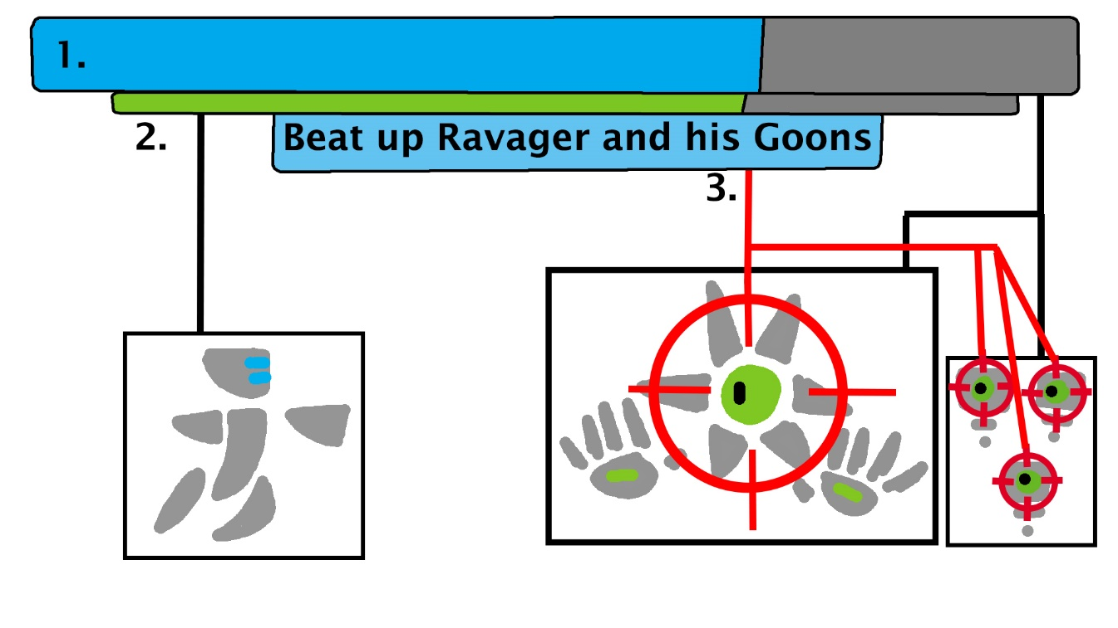

1: The Progress bar at the top of the screen visualizes the progress of your current task, serving as a boss health bar, an enemy count and quest status.

2: The Player health bar below the progress bar specifies the current health of your character, should it hit zero the game will reset back to the beginning of the level.

3: The Objective description specifies your current given task in order to progress through the level, in this example you’re supposed to eliminate all enemies including the boss.

**Pause Menu:**

The pause menu shows up in the middle of your screen whenever you press Esc which pauses everything that is currently happening in the game, and provides helpful settings and information.

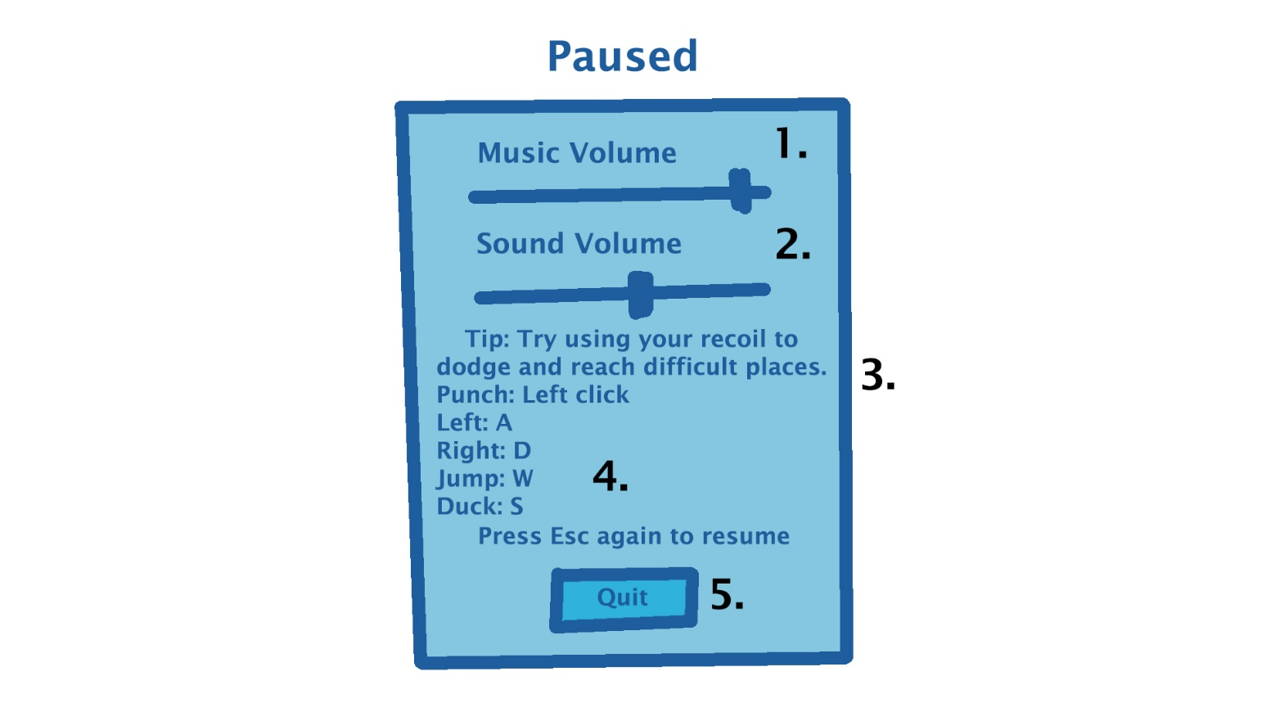

1: This scrolling bar allows you to adjust the volume of the music played ingame.

2: This scrolling bar allows you to adjust the volume of the sounds playing ingame.

3: This section of text randomly chooses a table of strings to provide helpful tips for new players who may struggle in a few levels.

4: This section of text describes the main controls in the game for players who forget the control scheme.

5: This button exits your current level and takes you back to the main menu, abandoning all progress you made in the level except for achievements.

**Speed Meter:**

A bar appears above the character’s head as the player launches 2+ punches in a row, which increases with the punching rate. This is usually accompanied with static text on the screen to describe the current speed you are punching in.

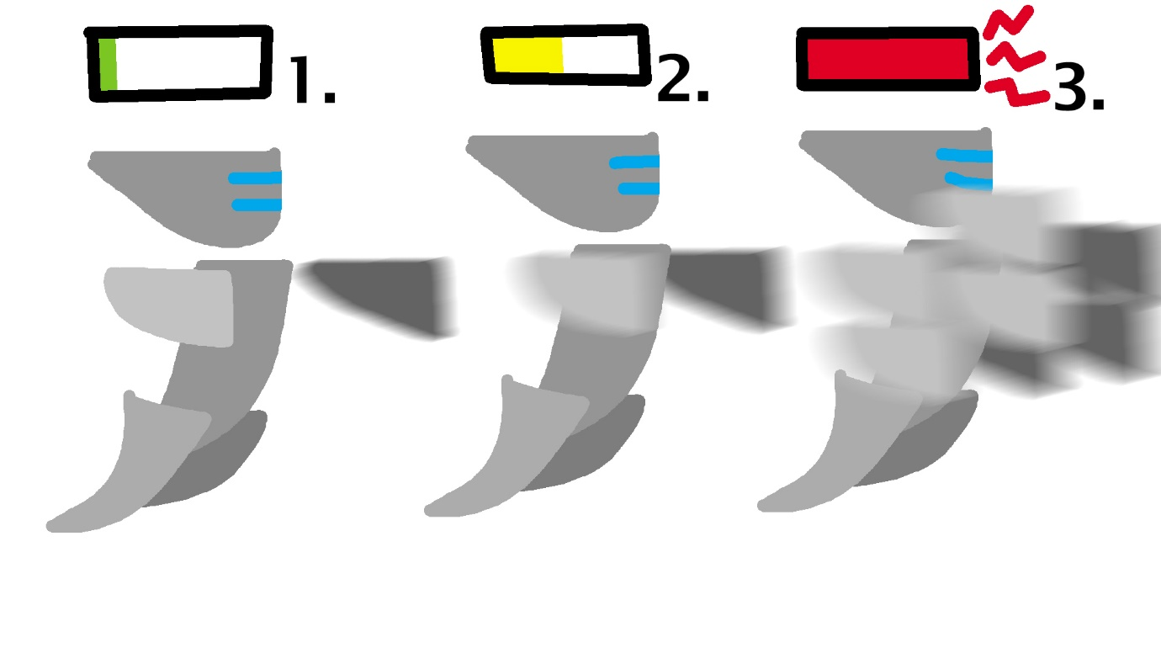

1: Because the player is punching at a slow speed, it stays green and very low, you would get a slow speed rank.

2: Because the player is punching in relatively quick succession, the bar turns yellow and sticks to the middle, you would get a fast speed rank.

3: Because the player is punching at a speed greater than anticipated, the bar turns red completely maxed out, appearing to leak at the right, you would get an extremely fast speed rank and an achievement.

**Power Meter:**

A bar appears above the fist you are holding as it reels back to charge, adding extra electrical particles as it charges and the bar fills up as you hold click.

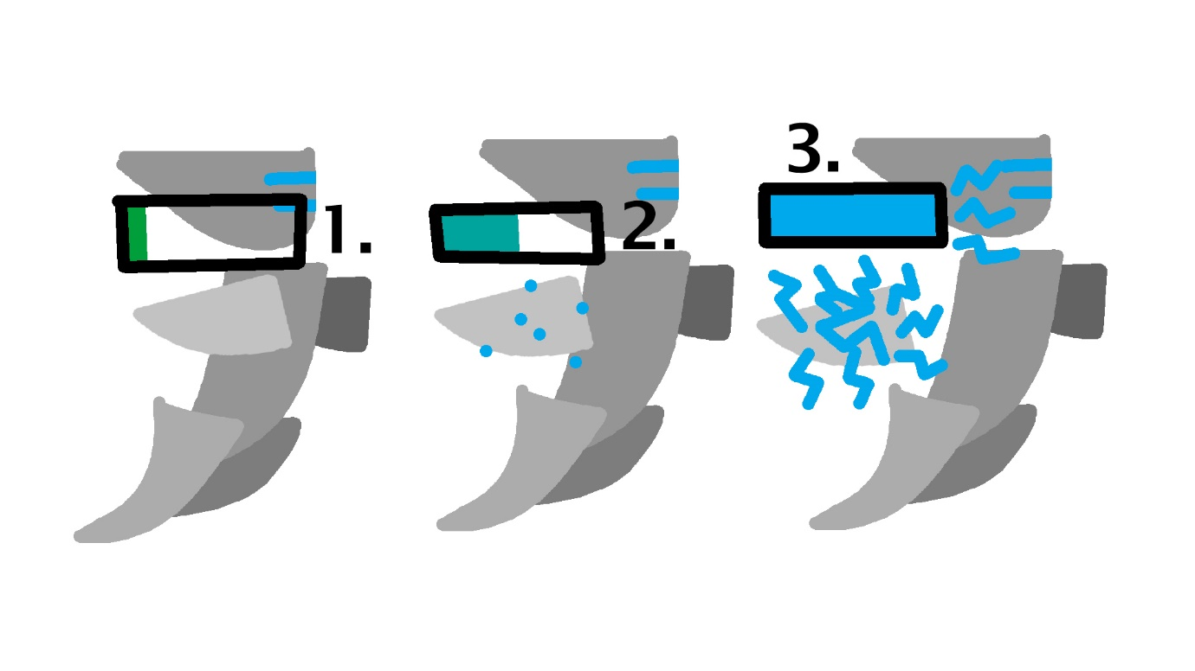

1: The fist is reeled back slightly and the bar is at green, it won’t do much damage.

2: The fist is reeled back half way from holding for 2.5 seconds and the bar is now a mix of green and blue from being half full, it will do half its maximum damage.

3: The fist is fully reeled back from holding for 5+ seconds, the bar is now blue and full, and it will do maximum damage. The charging will not progress any further after 5 seconds.

**Chat Bar**

The chat bar appears in the bottom left corner of your screen, which functions as NPC dialogue between the player and the other NPCs, allowing for more detailed descriptions in tasks given and to display character personalities.

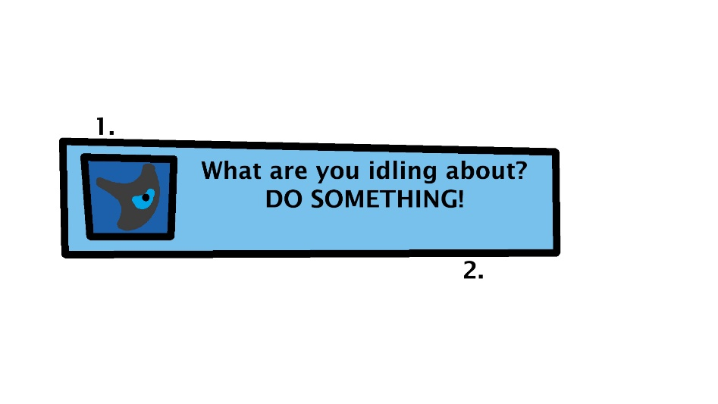

1: The icon that displays the face of the NPC that is currently talking to you.

2: The text dialogue that displays what the NPC is saying.

**Enemy Health:**

A bar appears above all killable non-boss enemies as soon as they take damage, and visualizes the amount of health an enemy has left until it falls apart

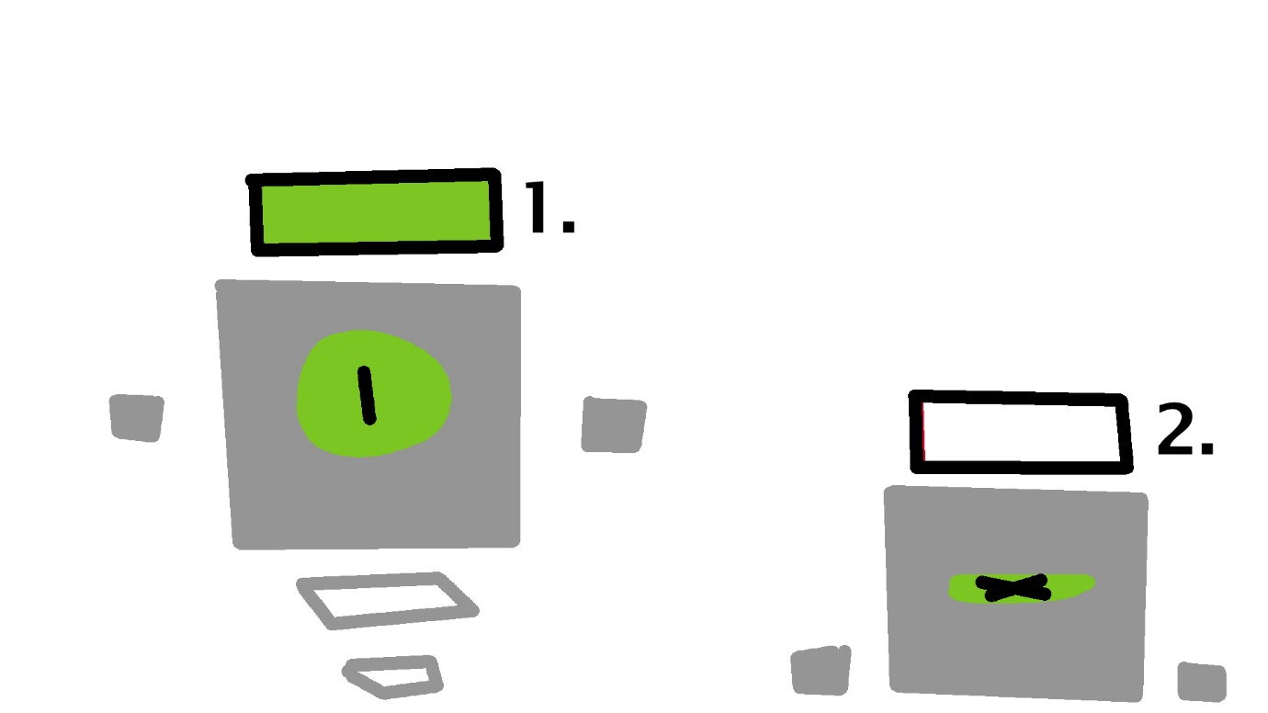

1: The enemy is at full green health.

2: The enemy has no health left, the bar turns red as it becomes empty.

Combat:

**Normal Punches:**

Regular punches that deal 1 damage per hit, they aim at the mouse and speed can vary. A speed meter above the character measures how fast your character is punching, and if the meter hits the maximum limit you gain an achievement for that and some shocked npcs.

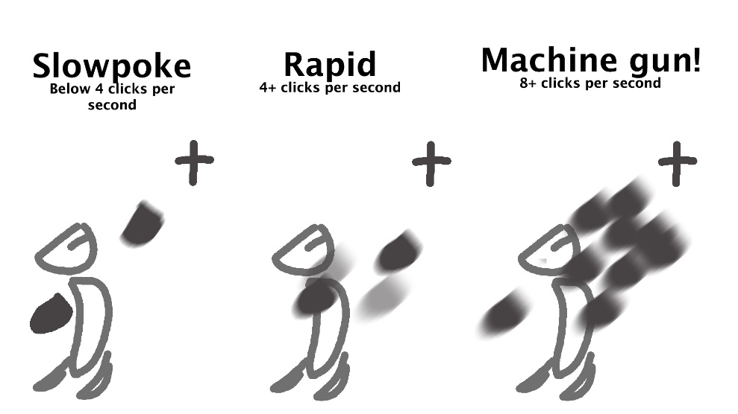

**Power Punches:**

Power punches require you to hold the mouse while aiming to charge up extra damage that can accumulate up to 20 damage in just 5 seconds. Power punches can also stun enemies as well as block boss melee attacks.

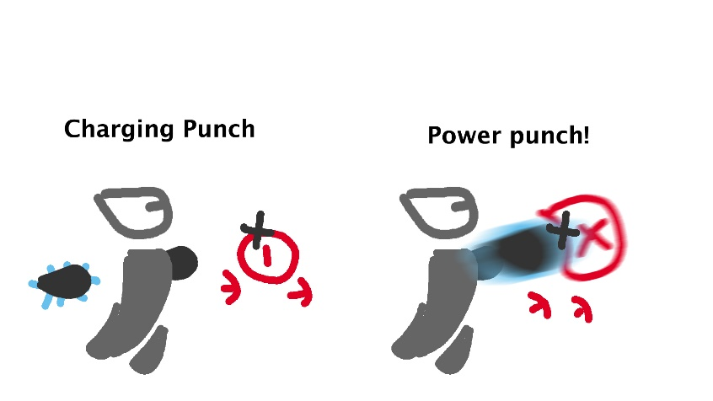

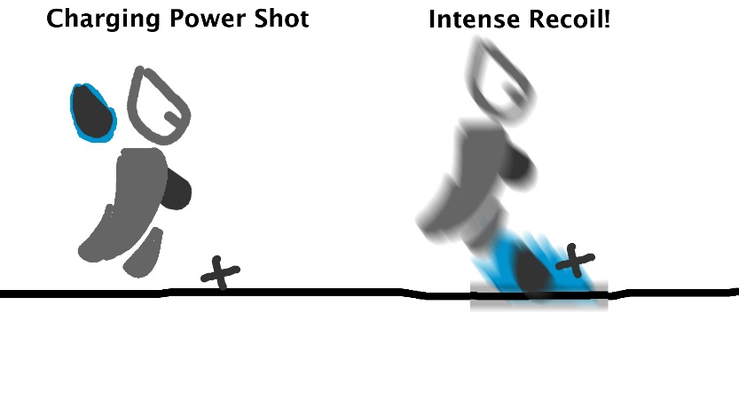

Level types:

**Chase:**

Swiftly bash through enemies and obstacles as a massive lethal unstoppable force closes in and escape it.

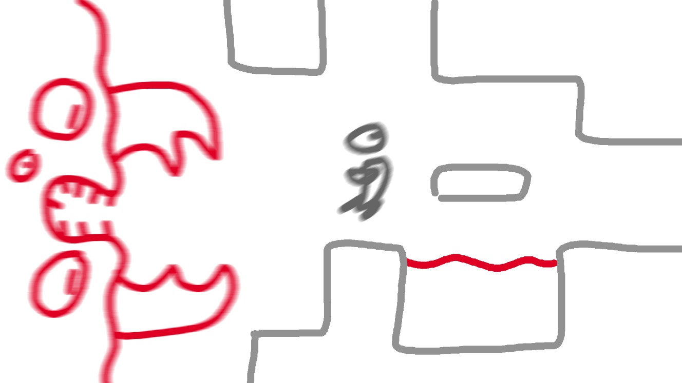

**Puzzle:**

Navigate through series of hazardous puzzles. Nothing bad is chasing you but don’t take too long otherwise the security protocols will kick in, spawning an enemy raid.

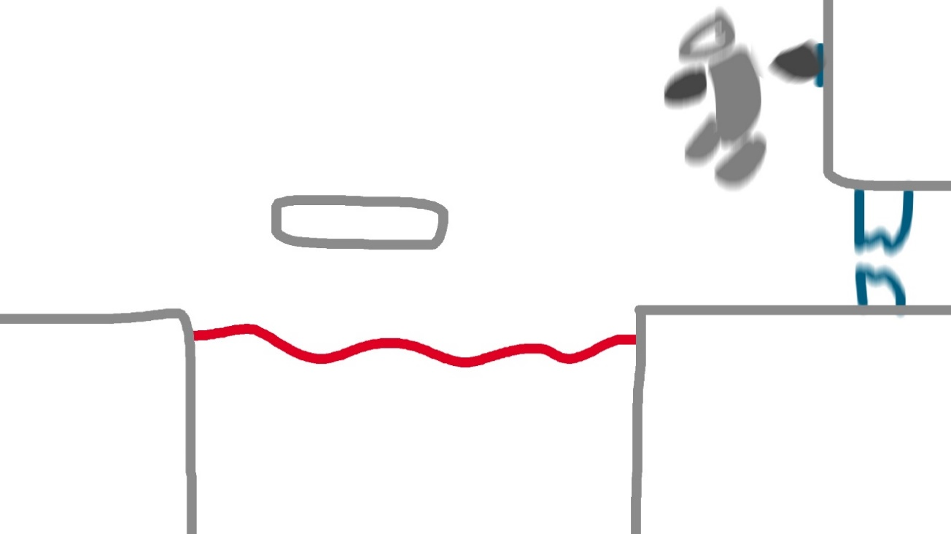

**Hunt:**

Massacre countless enemies in order to proceed to the next level.

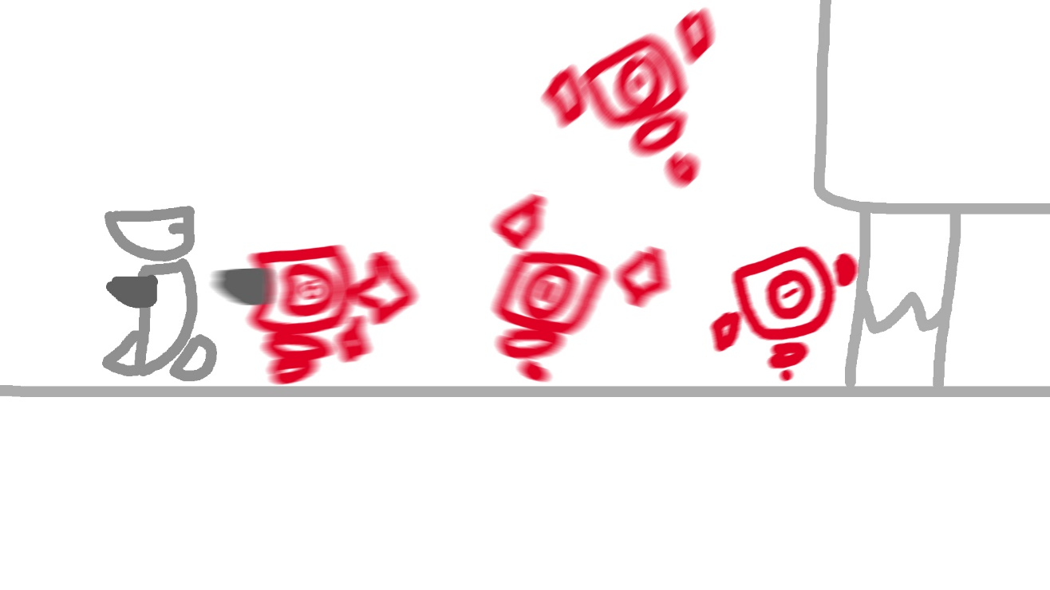

**Boss:**

Make your way to the boss’ chamber and bash up the boss.

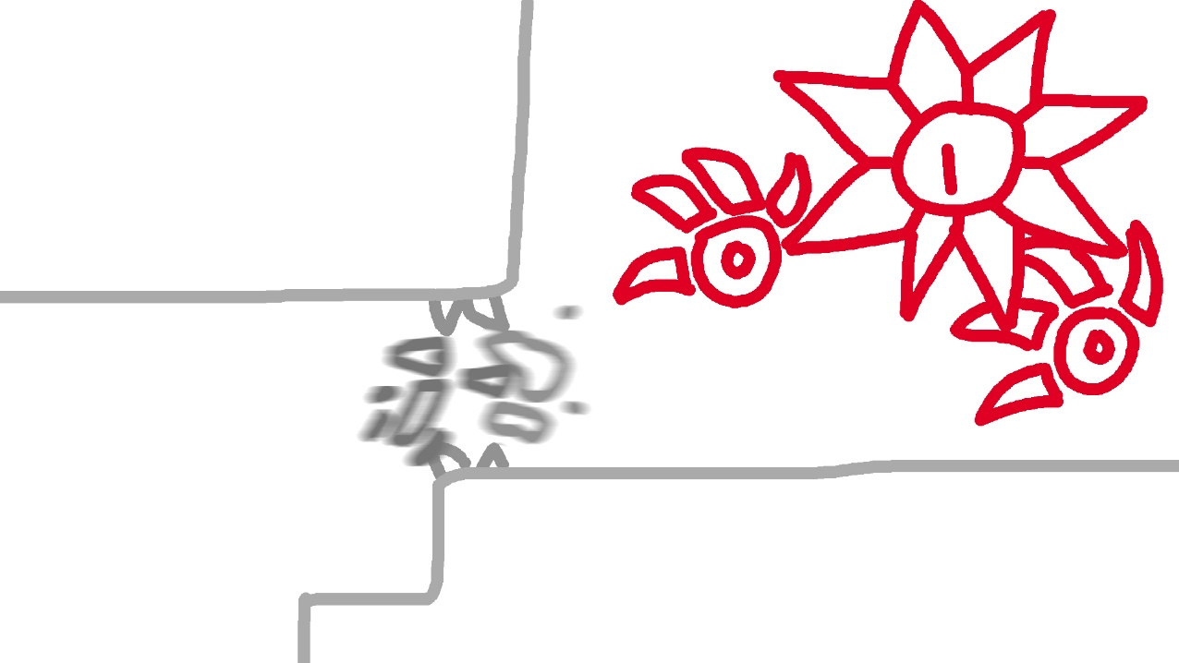

Puzzle Components:

**Acid Pit:**

Glowing green liquid that instantaneously kills you on touch.

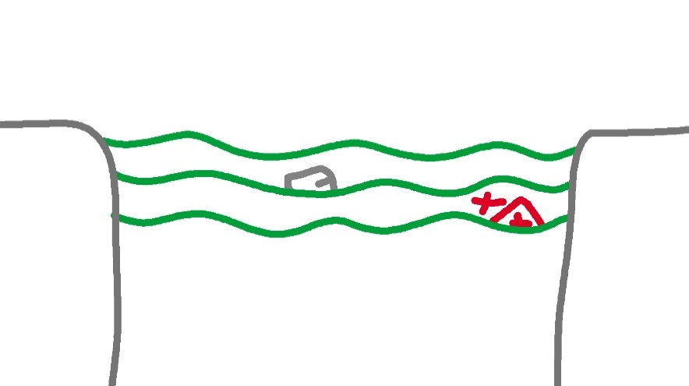

**Spike Trap:**

Spikes installed on the floor that extrudes and retracts in a fixed loop.

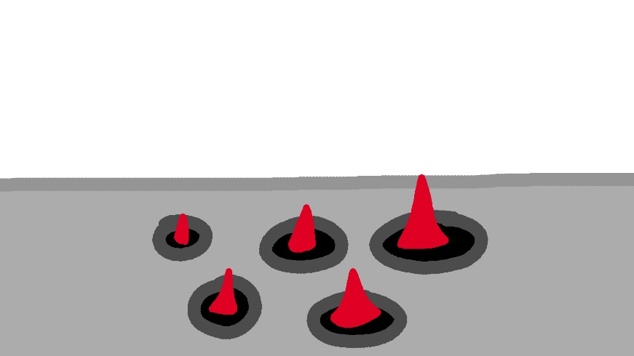

**Fake Walls:**

Destructible walls that look like real walls but shatter instead of inflicting recoil, often used to conceal entrances to key rooms.

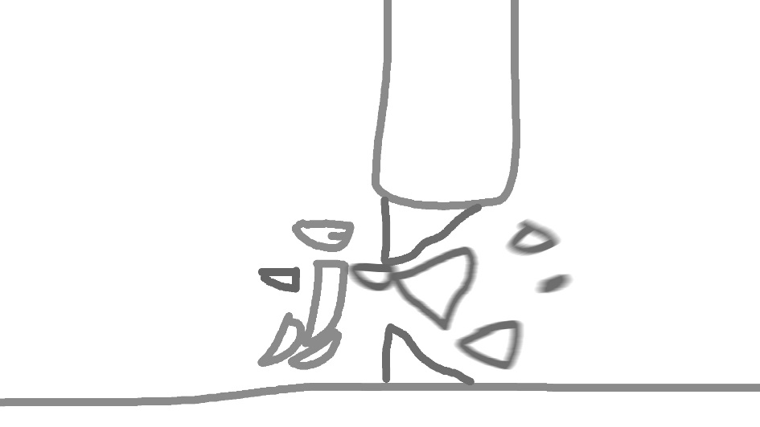

**Regular Buttons:**

Punch them in order to unlock the door it is connected to.

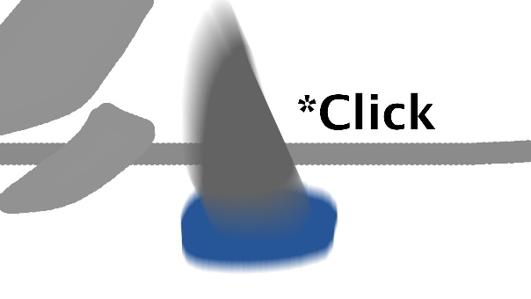

**Hidden Buttons:**

Buttons that are camouflaged to the wall it is attached to, extremely difficult to distinguish but functions like a regular button.

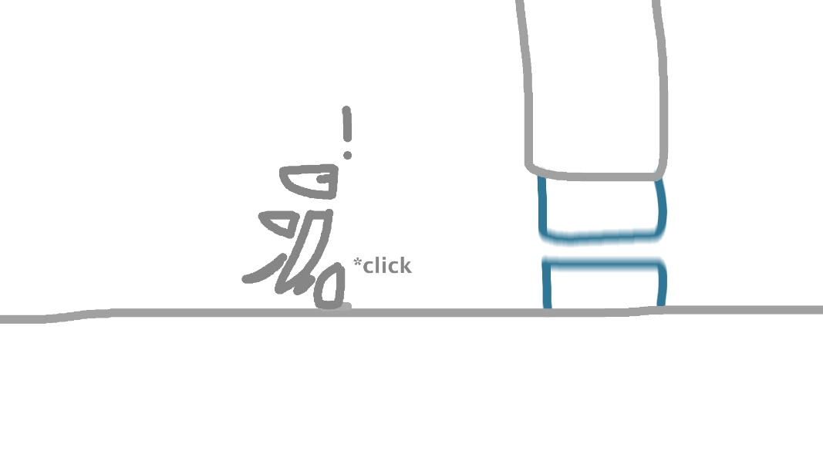

**Fake Buttons:**

Buttons that appear to do nothing when hit. Often used to hide real buttons.

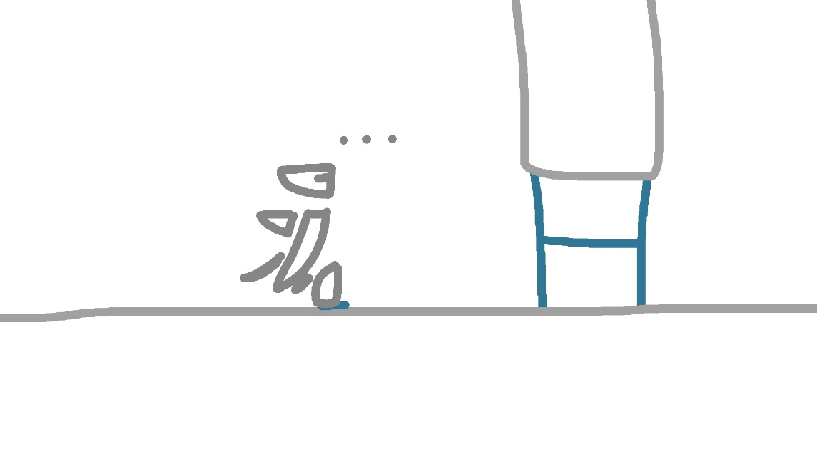

**Fluorescent Water:**

Glowing green liquid that imitates the Acid Pit, but is completely safe. Often used to hide buttons.

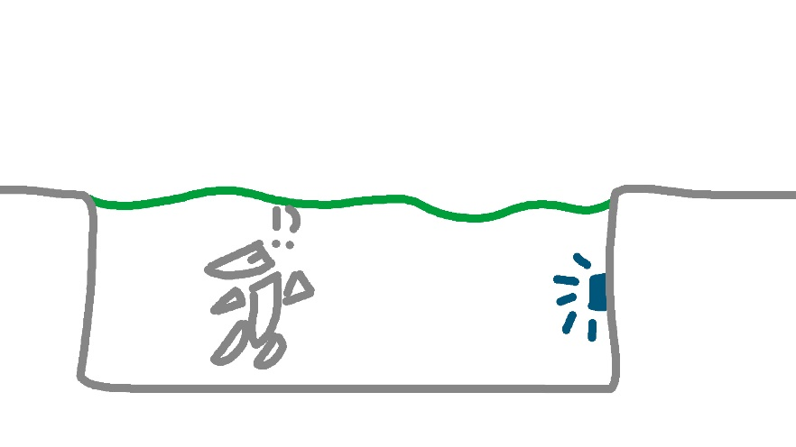

**Security Laser:**

Hazardous lasers that will deal damage and knockback to anything in the way.

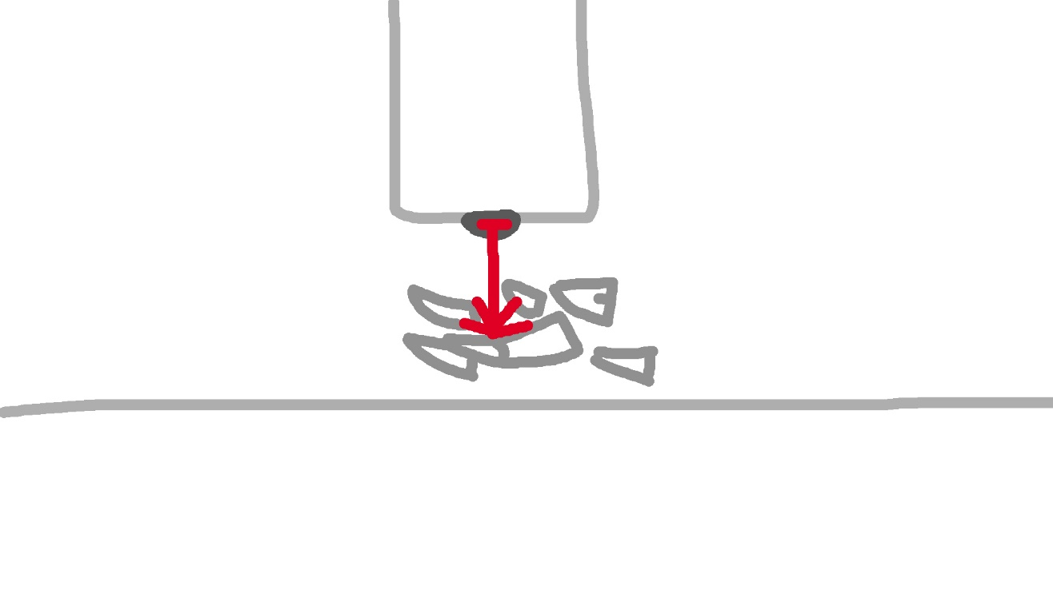

**Laser Pointer:**

Harmless version of the Security laser used to trick players into thinking that they are trapped.

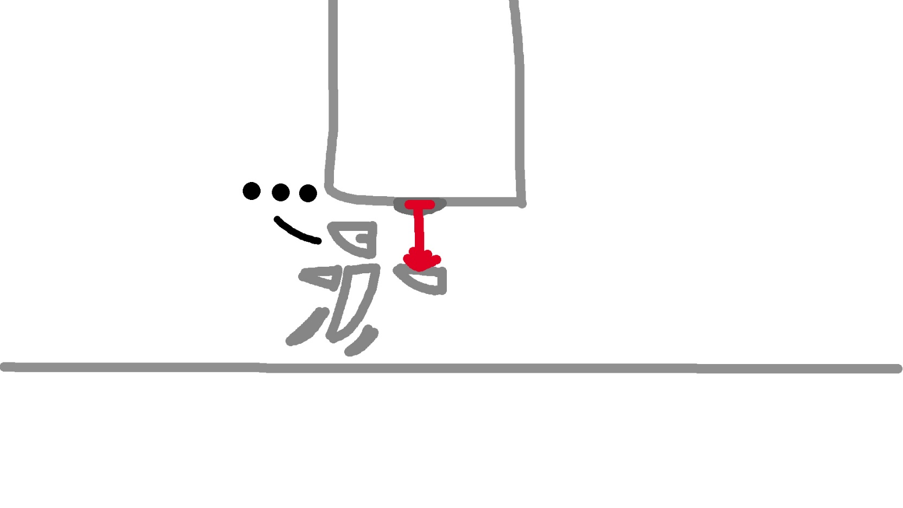

**Enemy Locked Doors:**

Doors that can only open when all the enemies in the specified room are eliminated.

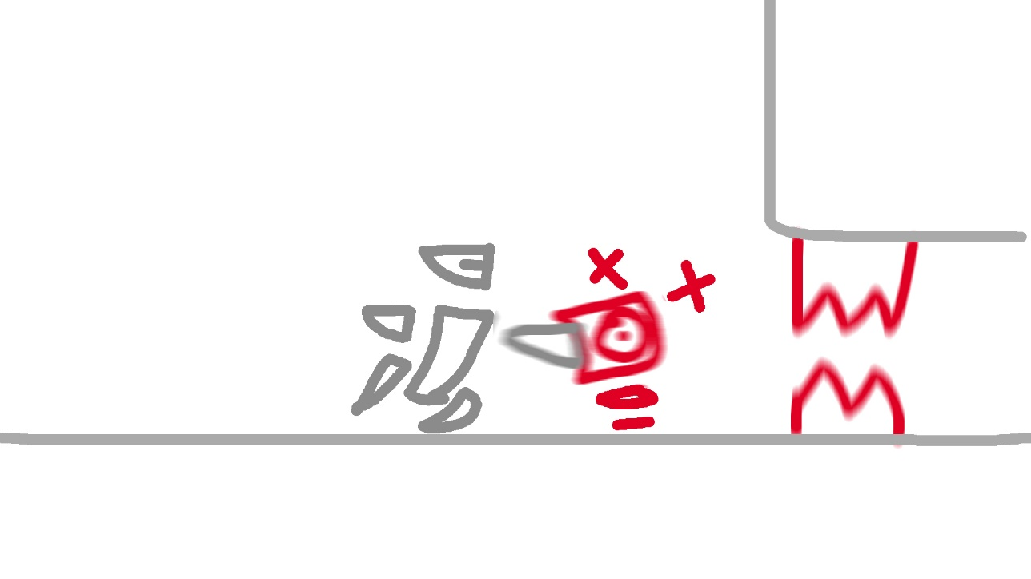

NPCs:

**Sergent123:**

Constantly sends messages through your user interface to instruct you throughout the game and comments on your actions and performance.

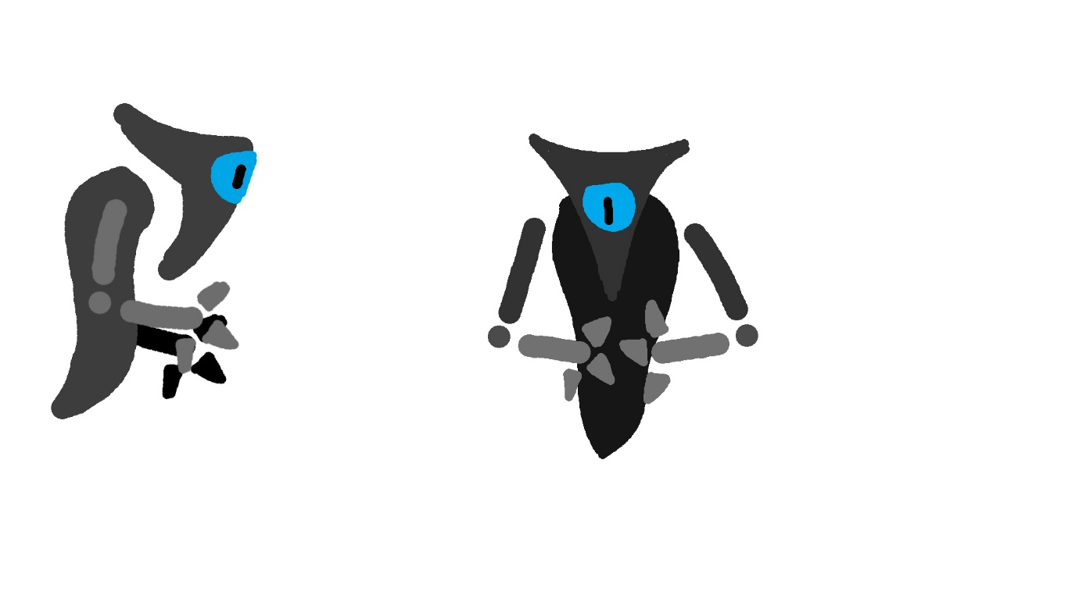

**Glitchy:**

The avatar of the game developer that is occasionally seen in the background watching the player and reacting to their every move. Has no true form and can only be seen through his observer form throughout the game. Will react to every achievement made by the player and talks to the player at the end of the game.



Enemies:

**Trainer Bot:**

Designed purely for taking hits, absolutely terrible at combat…

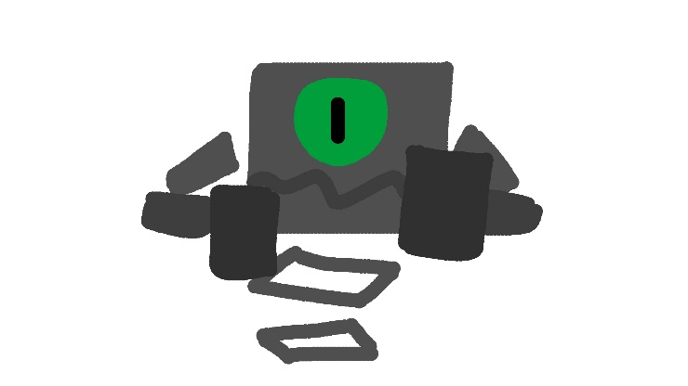

Health: 10, Damage: 1, Attack rate: 1

**Security Turret:**

Comes with all sorts of arsenal, but it simply cannot improvise and only fires at where it is programmed to fire.

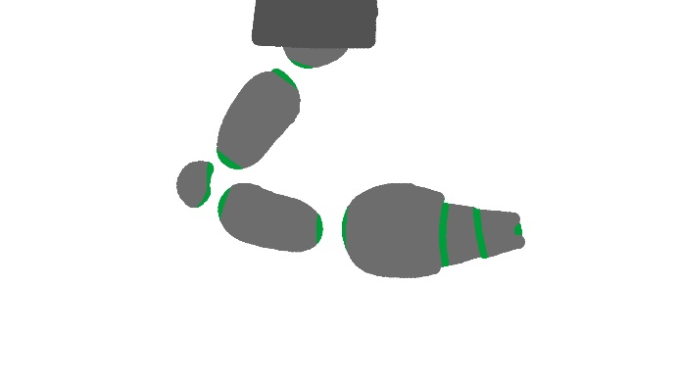

Health: 1, Damage & Speed: Varies with weapon

**Door Keeper:**

Often found above doors to keep them sealed and shoot down intruders.

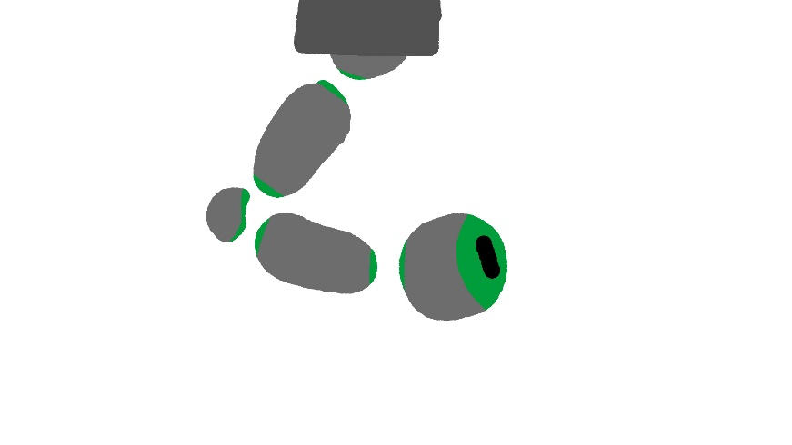

Health: 1, Damage: 2, Attack rate: 1

**Door Guardian:**

The last door keeper in each non-boss level, if the exit room is not guarded by a boss then it is guarded by this miniboss. Always shoots multiple projectiles at once.

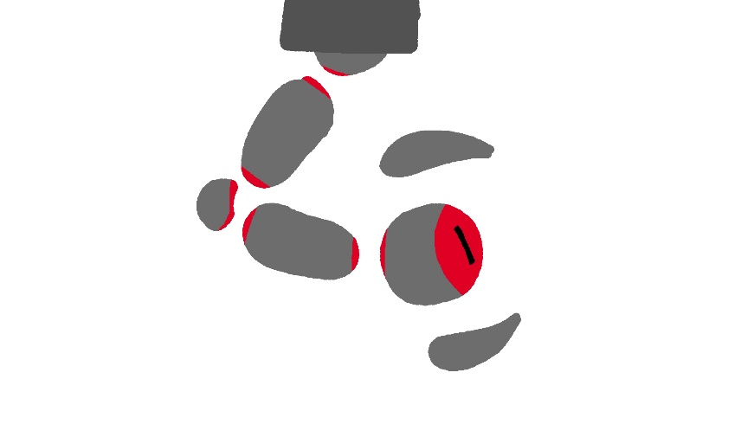

Health: 20, Damage: 5, Attack rate: 0.5

**Proto Crawler:**

Capable of crawling up walls and ceilings, it uses its mandibles like scissors to cut down its enemies.

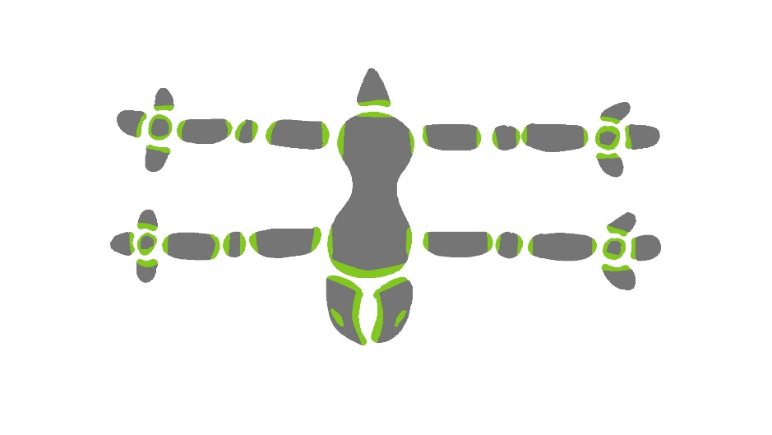

Health: 5, Damage: 2, Attack rate: 4

**Proto Brawler:**

An intelligent automated model that actively hunts down the player by navigating the room and even jumping, Capable of delivering hard blows despite its slow speed.

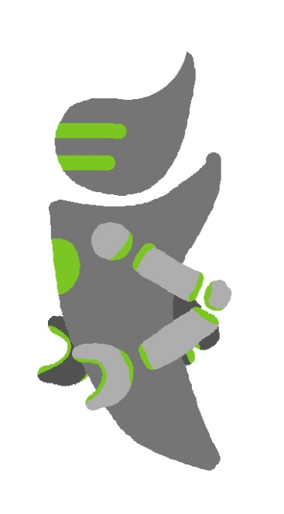

Health: 15, Damage: 4, Attack rate: 2

**Proto Slinger:**

A hovering smart weapon that charges a powerful laser at the player. Best to take cover as quickly as possible.

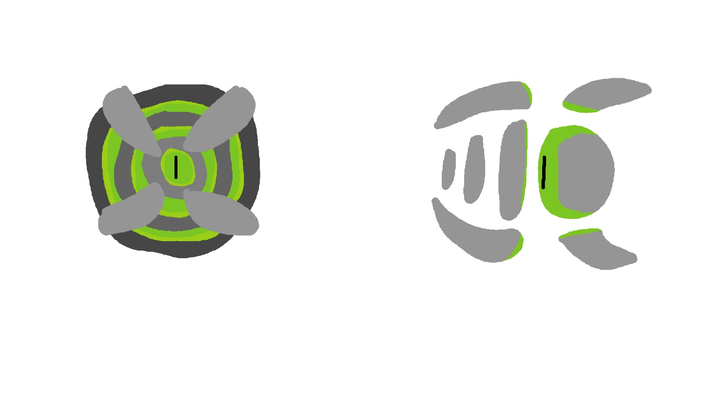

Health: 1, Damage: 10, Attack rate: 0.1

**Digger:**

Alien worm that fixates on a specific spot for a given time constantly spitting acid at the player or biting them if in range, before digging back down again to pick another special spot to attack from.

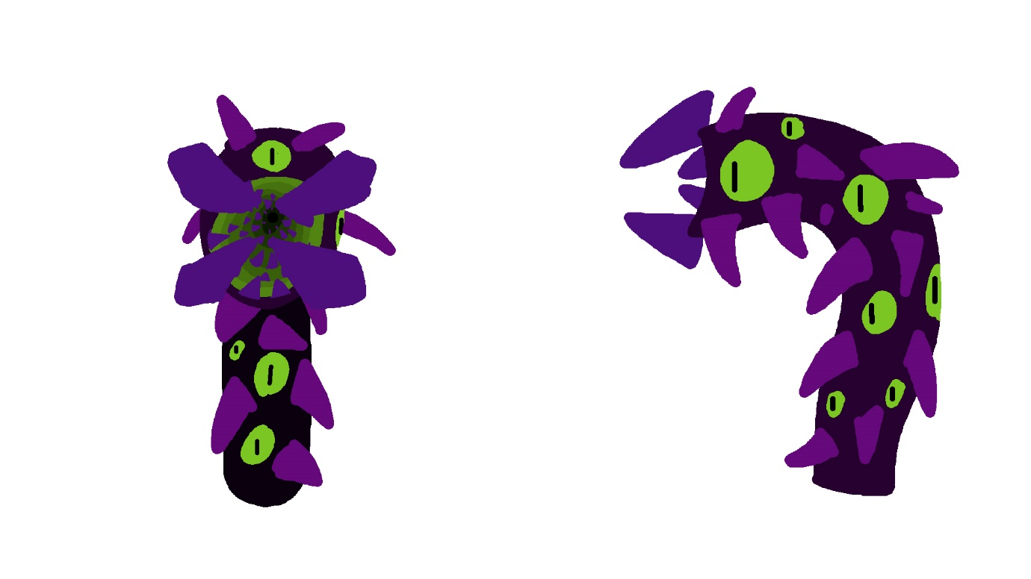

Health: 20, Damage: 8 (Melee), 4 (Ranged), Attack rate: 1

**Viral Tendrils:**

Alien tendrils that constantly changes position every few seconds and attempts to thrash at the player.

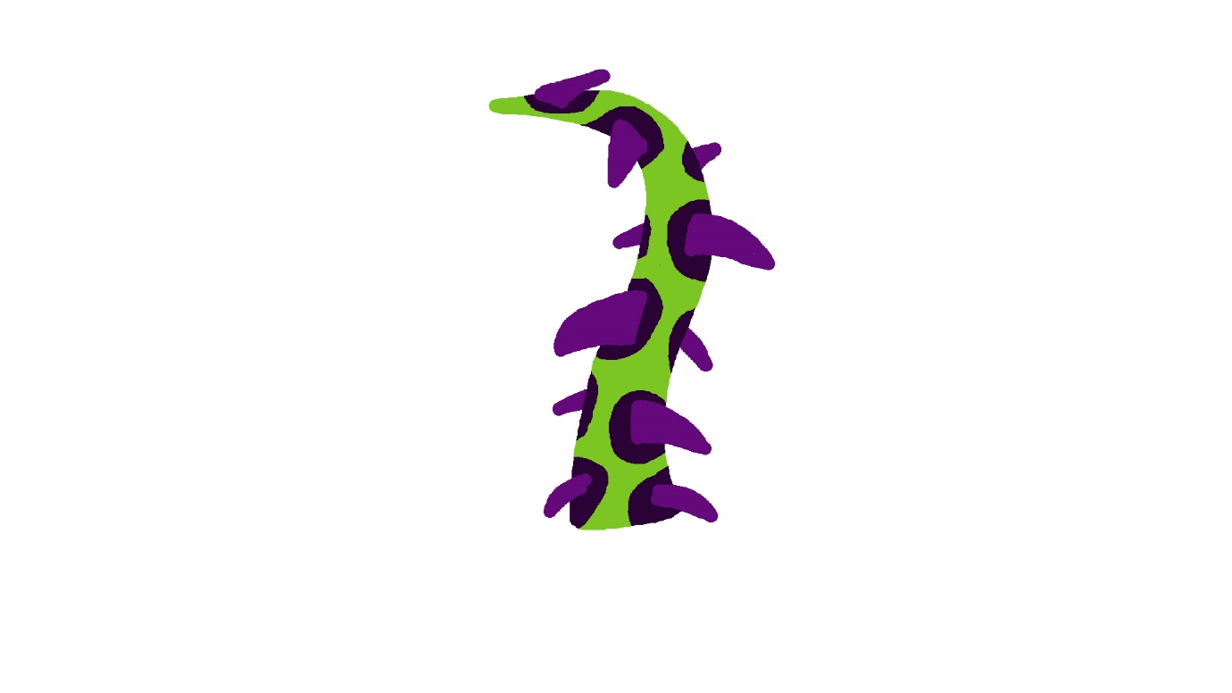

Health: 30, Damage: 10, Attack rate: 2

Bosses:

**Ravager:**

A powerful prototype machine that utilizes its laser eye and levitating hands to attack.

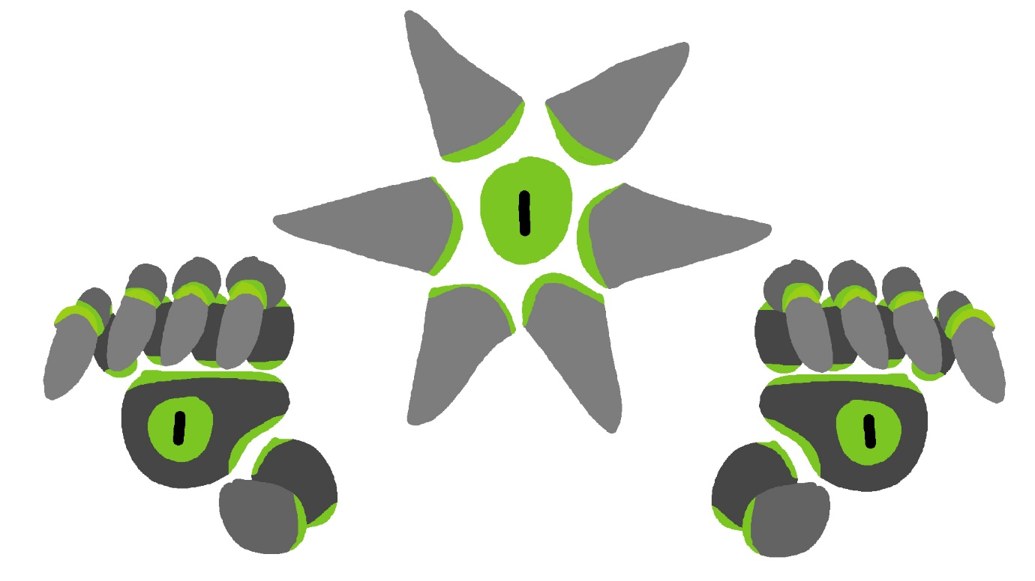

Phase 1: (Health: 80, Base Damage: 5)

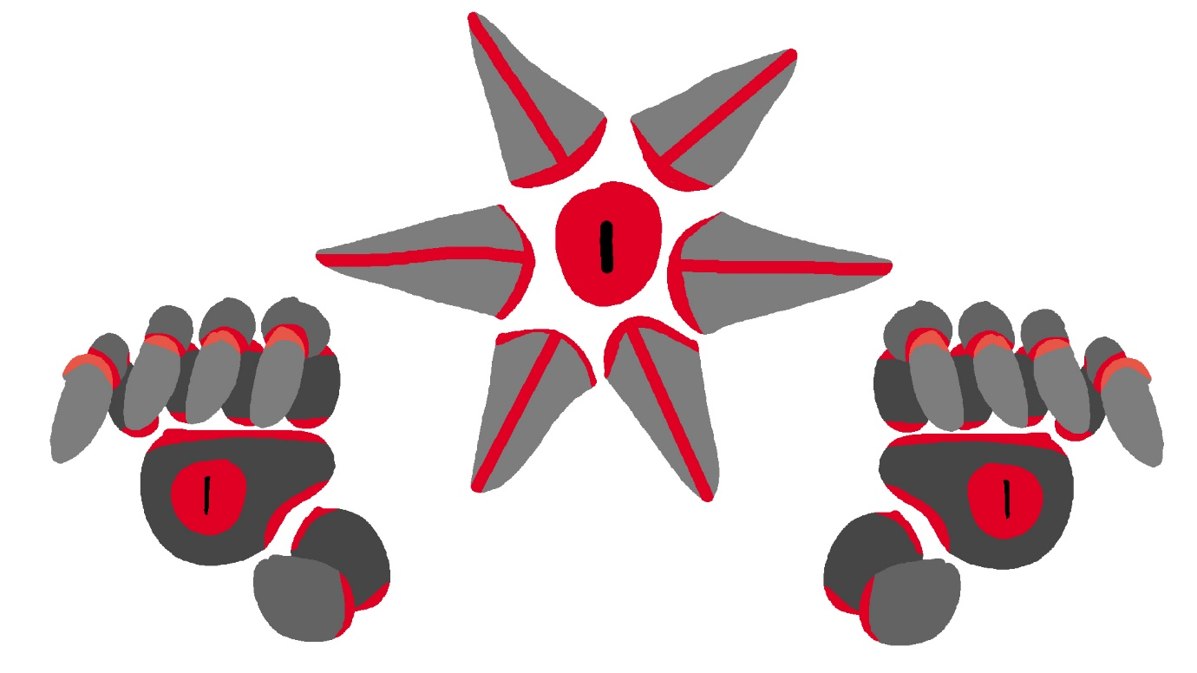

Phase 2: (Health: 120, Base Damage: 6)

**ARM:**

A mechanical arm initially designed to manage the storage module, it uses its own hand for melee purposes and the eye in its palm for lasers.

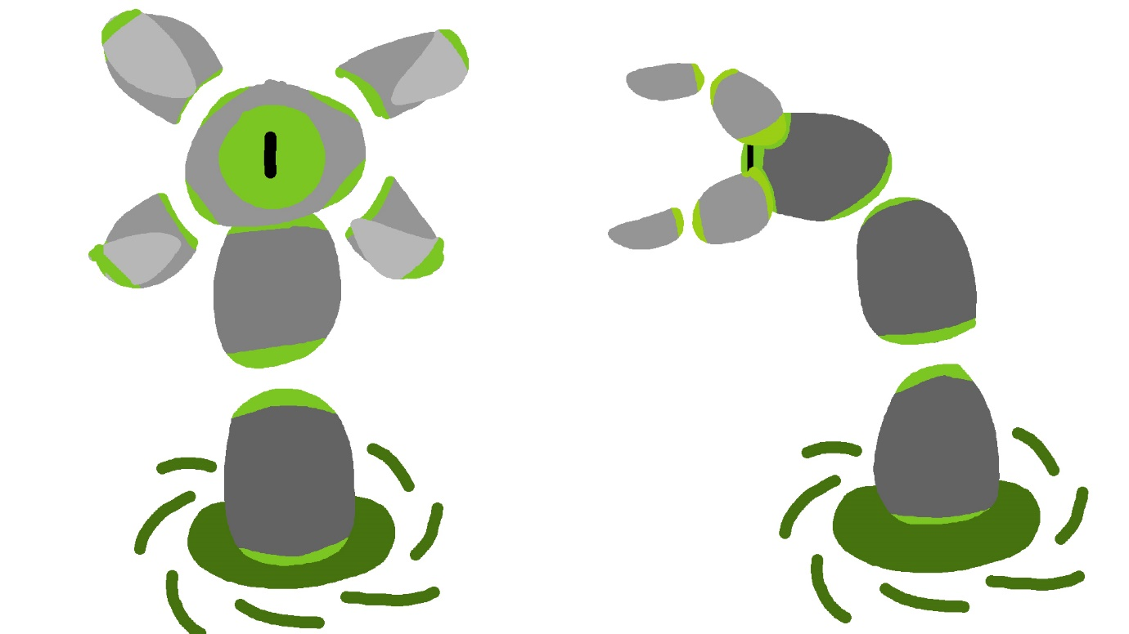

Phase 1: (Health: 120, Base Damage 10)

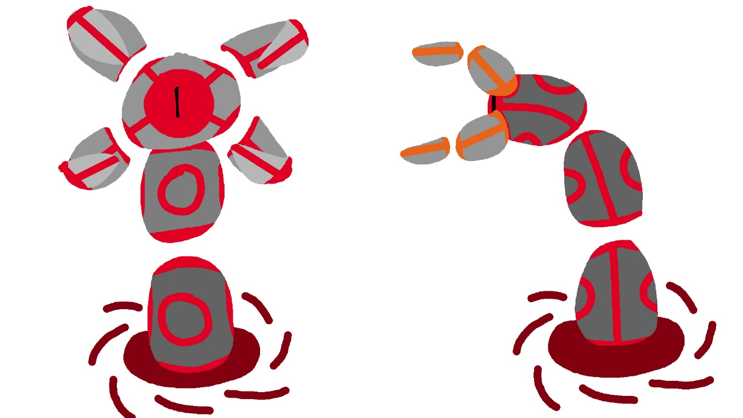

Phase 2: (Health: 180, Base Damage 11)

**Blackheart:**

A massive bio-mechanical heart that deploys tendrils to infect many modules. Starts fixated on the ceiling but detaching it will force it to use its tendrils to chase you.

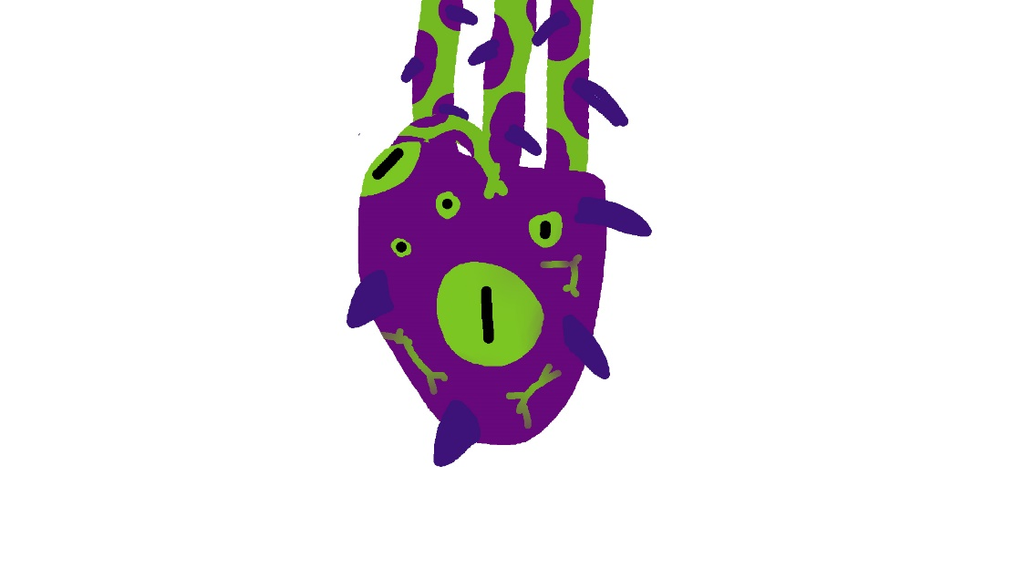

Phase 1: (Health: 80, Base Damage 20)

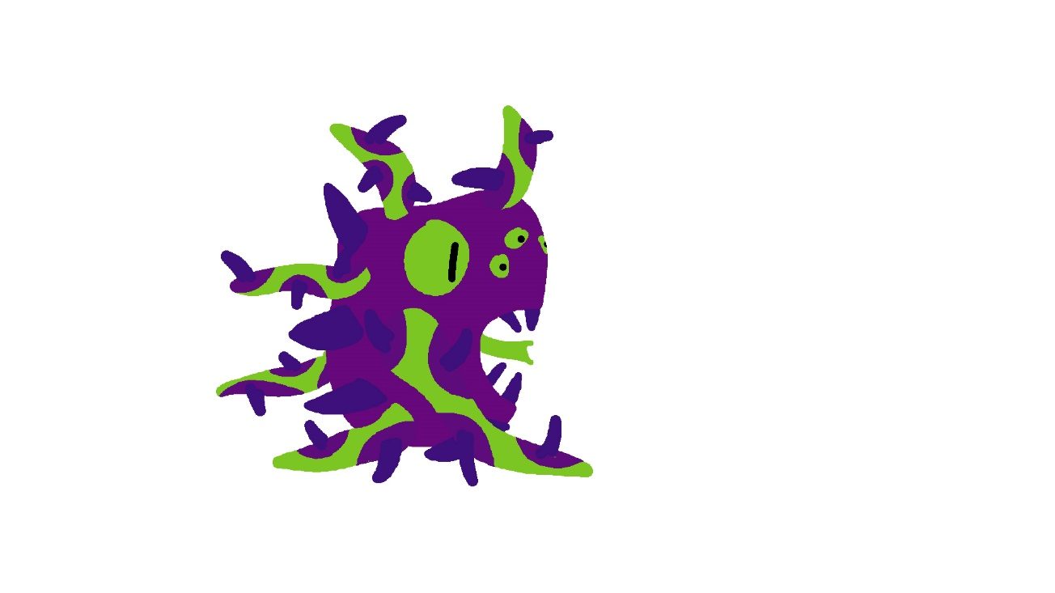

Phase 2: (Health: 320, Base Damage 25)

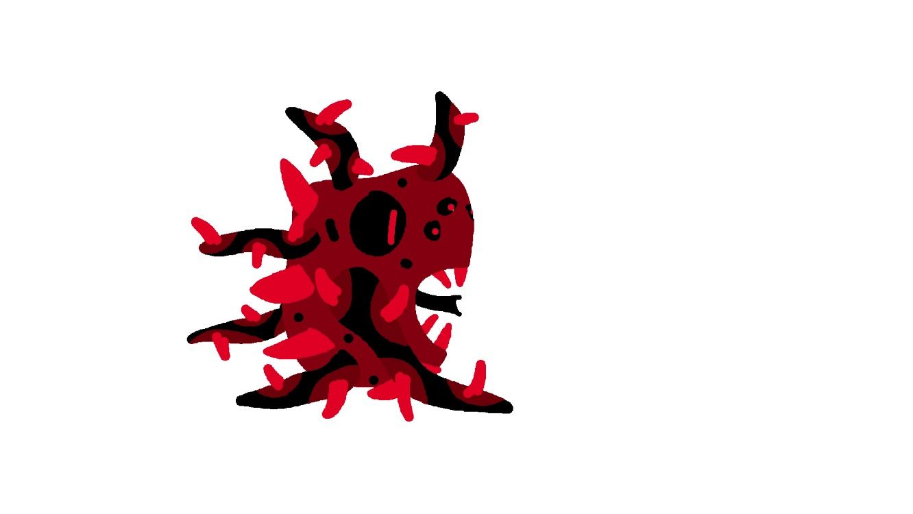

Phase 3: (Health: 100, Base Damage 30)

**Crimson.exe:**

Sophisticated virus that created blackheart to infect the mainframe. This entity is bound to the 4th wall and unaware that it is actually in a videogame. Damage dealt to this entity lingers even after closing and reopening the game. It passively and actively tampers with the game’s rules, including but not limited to: obstructing some of the player’s view, having absolutely no health bar, never leaving itself open to melee attack, forcefully unpausing the game. It never uses its own attacks and mimics attacks from all bosses you have fought in the game, also summoning red eye holograms that function like door guardians. Pausing the game will freeze all attacks, but it will not freeze Crimson.exe, but it will eventually get bored of trying to attack you and leave itself open to attack unknowingly, unless it is at half health in which it will attempt to unpause the game. Its presence lingers even at the beginning of the game, always lingering and intensifying over every achievement and level you complete, until you finish off Blackheart’s final form and confront it. It retains traits and strategies of all other bosses prior to this one, replicating not only their attacks but also their 4th wall breaking effects (For example, The Ravager may place one hand in front of the screen in effort to obstruct the player’s view of the arena). Defeating it will cause it to be replaced by a robotic version and unlock endless mode.

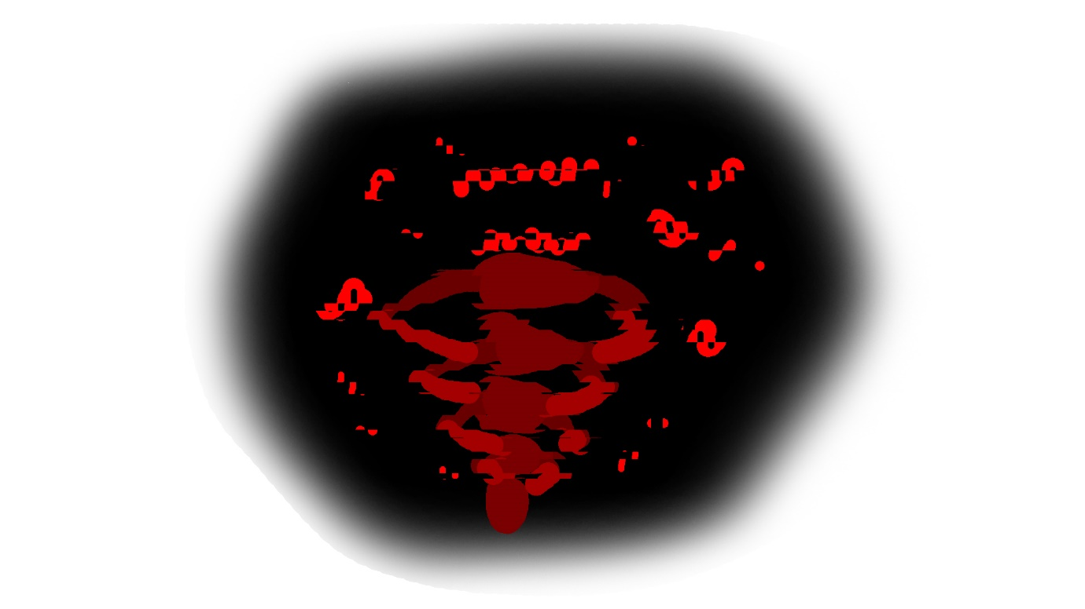

Health: ∞ (666), Damage: ∞ (1-50 Random)